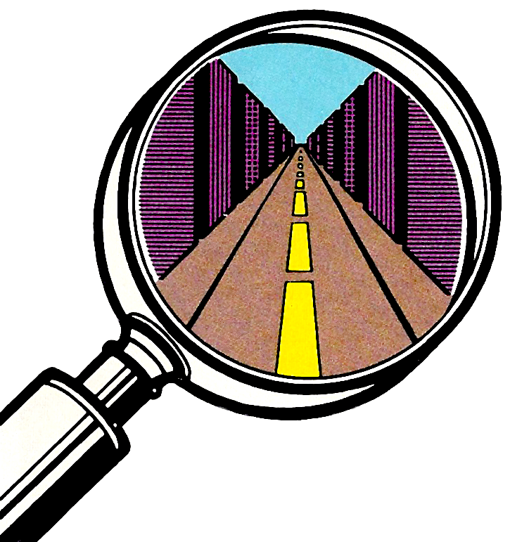

Action Fighter
Action Fighter
Action Fighter

Take the motorcycle from
"Hang On,™" equip it with hi-tech weaponry and give it the ability to transform itself into an aircraft or car—and you've got ACTION FIGHTER!
PLAYERS: 1 or 2
PERIPHERALS: Sega Control Pad or Control Stick
ARCADE

