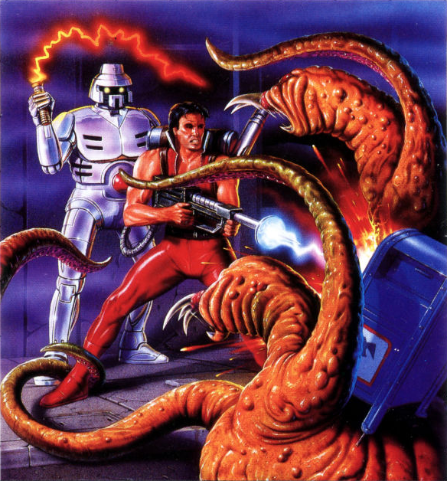

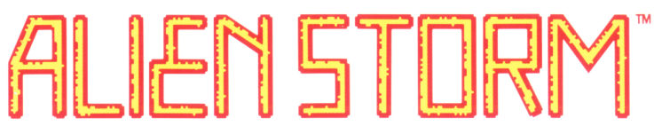
Alien Storm
Alien Storm

Shape-changing alien scum take over your city.

Fry the slimy horrors and smash their bid for global conquest.

Blast into action with fire blazers, electric whips and more!
PLAYERS: 1
PERIPHERALS: Sega Control Pad or Control Stick
ACTION

