

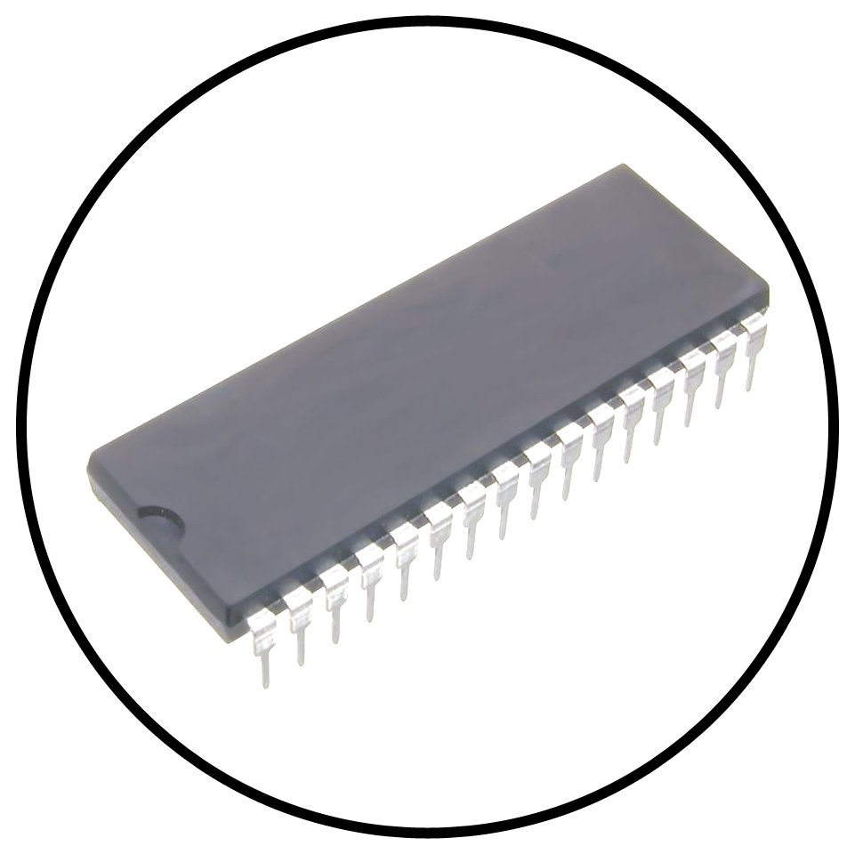
Development Cartridge
Master System
Development Cartridge
Development Cartridge

Use this cartridge to run software stored on a socketed DIP32 ROM.

The switch allows you to select between SEGA's MPR pinout and flash chip pinouts.

1Mb, 2Mb and 4Mb ROMs are all supported courtesy of the inclusion of SEGA’s 315-5235 memory mapper.
Compatible with:
SEGA MPR
29F010, 29F020, 29F040
49F010, 49F020, 49F040
UTILITY

