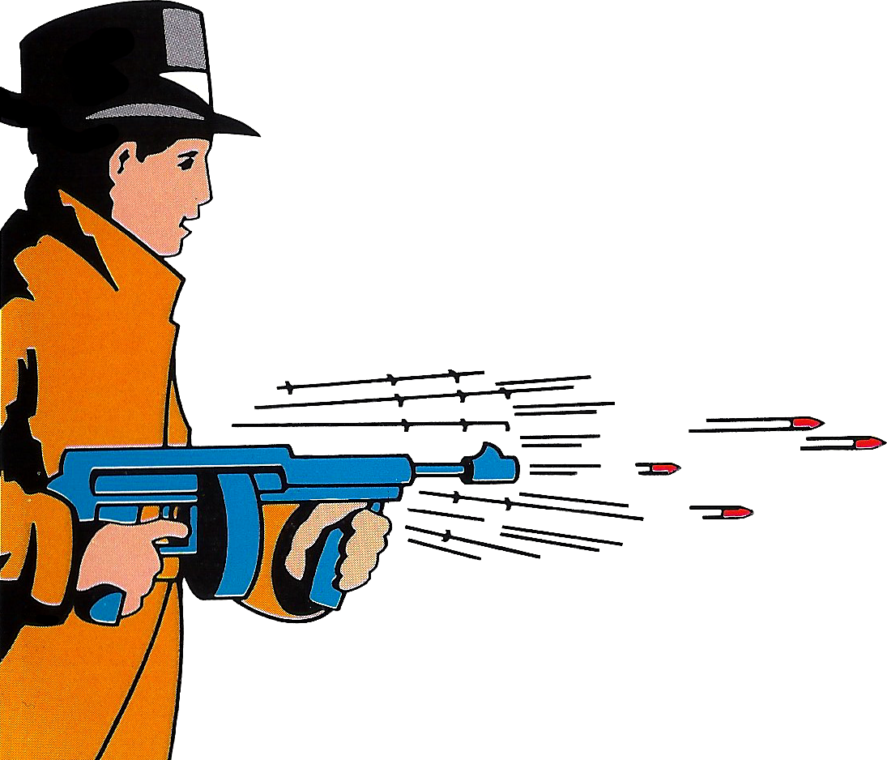

Gangster Town
Gangster Town
Gangster Town

In the 1920's working as an FBI agent, you are pursuing a gang engaged in smuggling.

After practising your marksmanship, shoot at the enemies in Car Chase, Downtown, Saloon and Night Club scenes.
PLAYERS: 1 or 2
PERIPHERALS: Sega Light Phaser
SHOOTING

