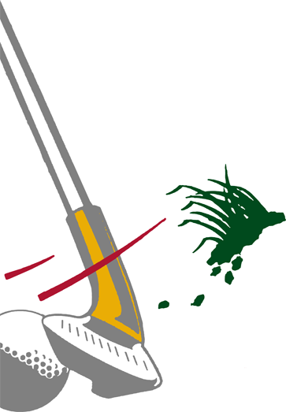

Great Golf
Great
Golf
Great Golf

Keep your head down. Eyes on the ball. Grip the club firmly...and swing. Welcome to the Sega Masters Tournament where you need to play better than "par" if you want to win.

You'll need nerves of steel for this course. Because shrewd thinking and raw talent are your only allies in this calculating competition.
PLAYERS: Up to 4
PERIPHERALS: Sega Control Pad or Control Stick
SPORTS

