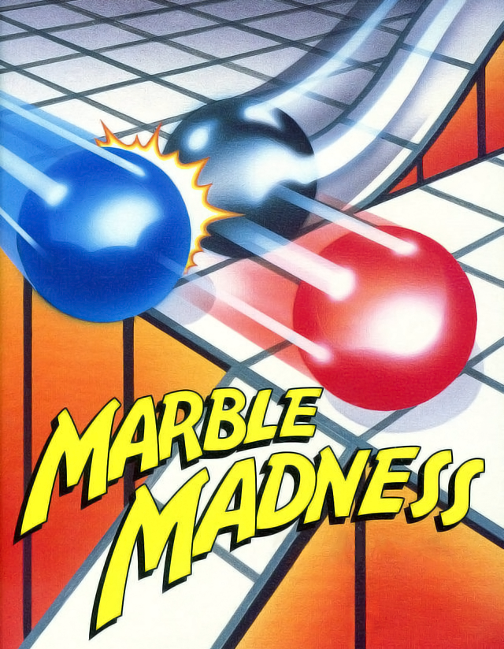

Marble Madness
Marble Madness

The arcade sensation of the '80s comes to your SEGA MASTER SYSTEM!

Have you got what it tales to guide a lone marble through six weird and wonderful courses packed with odd obstacles and insane indestructible inhabitants?

Find out in Marble Madness!
PLAYERS: 1
PERIPHERALS: Sega Control Pad or Control Stick
ARCADE

