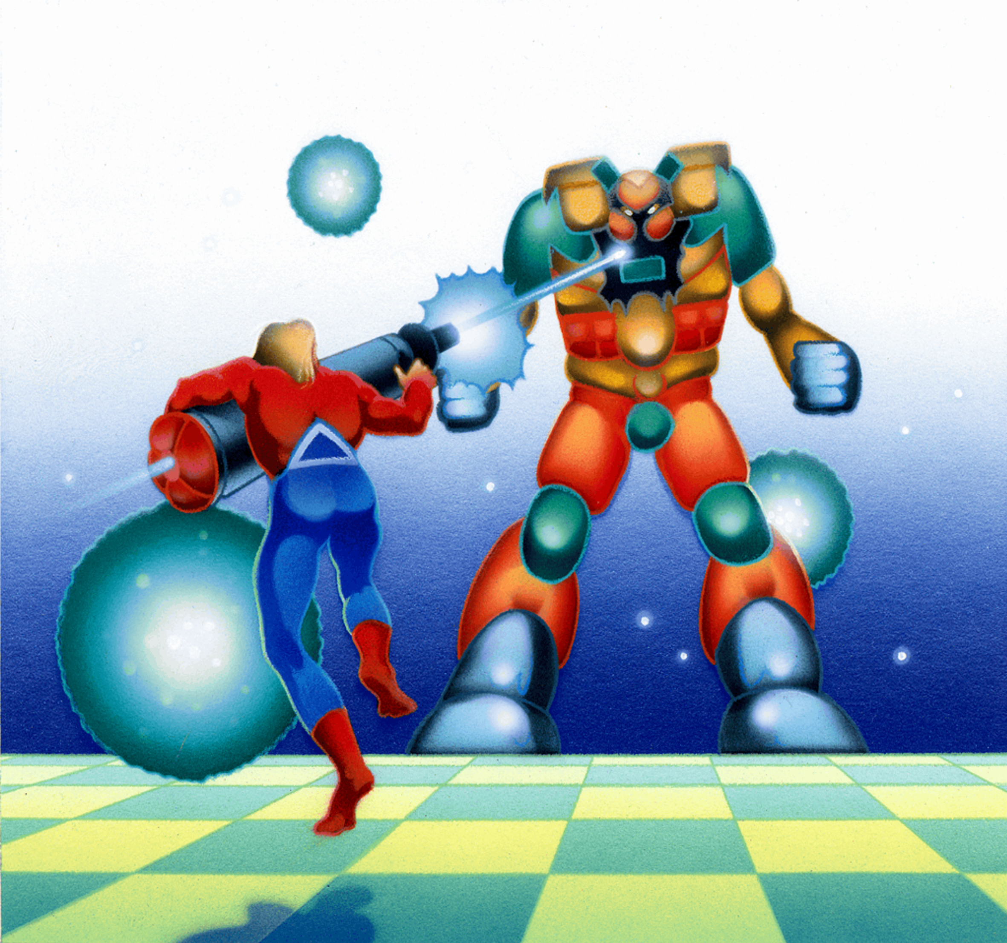
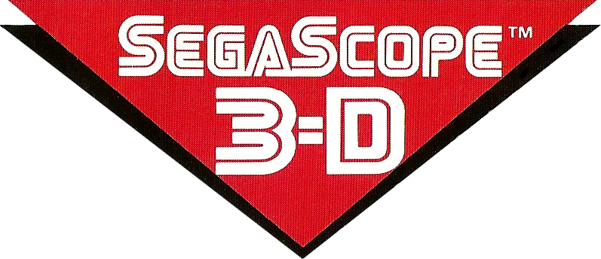


Space Harrier 3-D
3-D
Space Harrier 3-D

The Land of the Dragons is under attack! The rightful Prince of the Dragons, Euria, has been kidnapped

Only one person has the courage to go farther into the Land of the Dragons than any human has ever been before.

You...the Space Harrier.

But beware! The enemy knows you are coming...and they're waiting.
PLAYERS: 1
PERIPHERALS: Sega Control Pad or Control Stick,
3-D Glasses Required
SHOOTING

